Practical activity: Limonene Distillation
Practical Guide – Limonene Distillation

Aim: To extract limonene oil from orange rind and test for saturation
Notes and guidance
You may wish to have students collect the equipment for this themselves from communal trays at the front of the lab. This will help them to develop their skills of equipment recognition and organisation. However, if this is impractical, ask your technician colleagues if they are able to set up individual sets at student workstations.

This is a relatively complex and demanding practical that may not be suitable for every class. Consider doing this as a demonstration, especially if class sets of good quality distillation apparatus are not readily available.

Distillation can be carried out with side-arm test tubes and distillation flasks, but for best results, use quik-fit-style apparatus as illustrated in the diagram below.
Risk Assessment Notes
A risk assessment must be completed for this practical. The risk assessment should be specific to the class involved and written only by the teaching member of staff. For more guidance refer to CLEAPSS. It is good practice for students to wear safety spectacles during all class practicals and demos.

Take time to remind pupils that they should not consume any of the orange or the limonene oil. Eating and drinking in labs should be forbidden.

Cyclohexene, cyclohexane, and bromine water are hazardous chemicals. See CLEAPSS Hazcard HC045c for cyclohexene and cyclohexane and CLEAPSS Hazcard HC015b for bromine water.

The bromine water test should be carried out as a teacher demonstration only.
Equipment Per Group | Distillation Apparatus Setup  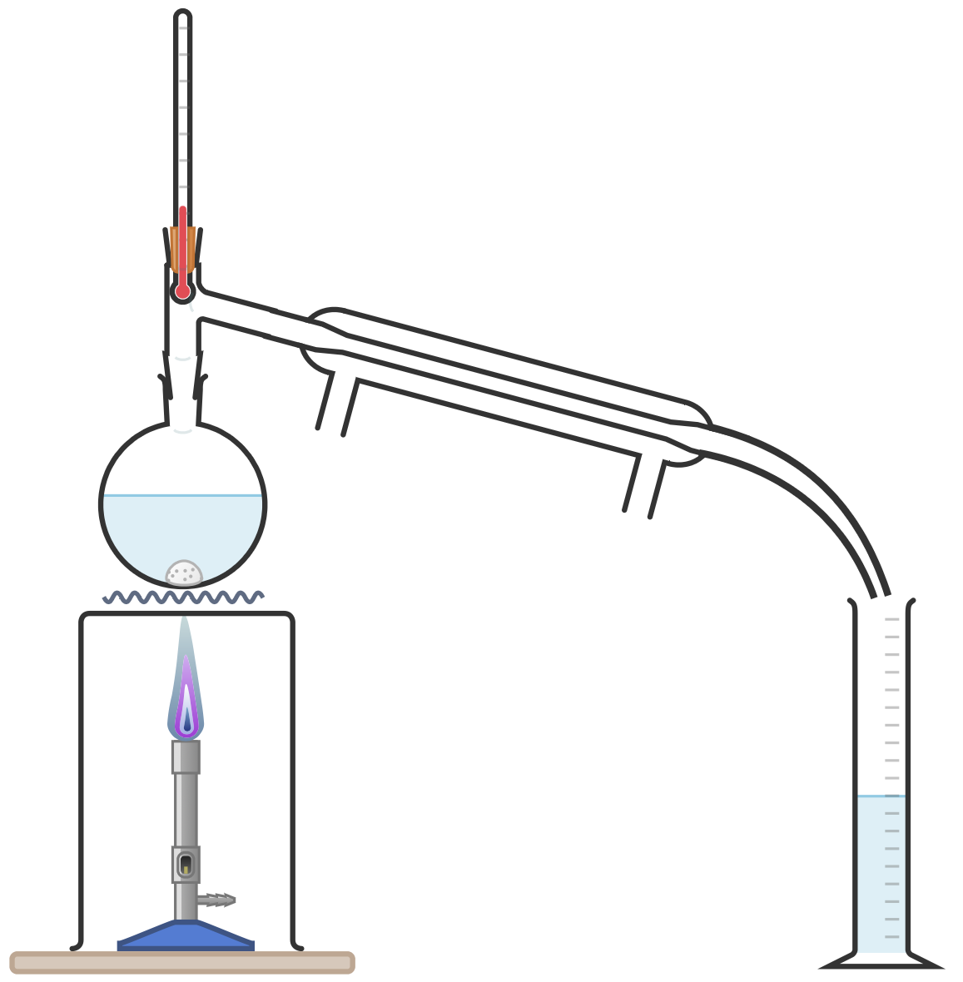
Apparatus:
- Bunsen burner
- Heatproof mat
- Tripod and gauze
- Thermometer
- Measuring cylinders (100 ml and 50 ml)
- 250 ml round-bottomed flask
- Quik-fit distillation apparatus with condenser
- Test tubes and bungs
- Pipette
- Spatula
- Grater

Chemicals:
- Orange
- Anti-bumping granules
- Distilled water
- Bromine water <0.2% v/v
- Cyclohexene
- Cyclohexane

Method |  | Questions To Ask Students During The Practical
- Grate the outer rind of two oranges.  - Place this rind into the round-bottomed flask along with 100 ml of distilled water and a spatula of anti-bumping granules.  - Set up the distillation apparatus as per the equipment diagram.  - Light the Bunsen burner and heat the flask, taking care to keep the rate of distillation at approximately one drop per second.  - After approximately 50 ml of distillate has been collected, switch off the Bunsen burner.  - Remove the oil layer from the surface of the distillate using a pipette.  - Add this oil to a test tube for testing.  SMELL TEST – take a full breath in so your lungs are full. Then hold the test tube near your face and waft the smell towards you. Do so cautiously to avoid breathing in fumes from the test tube.  BROMINE WATER TEST (TEACHER ONLY) – add 1 ml of bromine water to three test tubes. Then, add a few drops of cyclohexane to one, cyclohexene to another, and limonene oil to the third. Insert the bungs and shake the test tubes. In the cases where the molecule contains double bonds, the bromine water will decolourise. |  | - How can we safely smell the collected oil? (Hold the test tube somewhat away from our face and waft the smell towards us with one hand. Try to fully breathe in before smelling the fumes to avoid inhaling.)  - Describe the limone oil? (At room temperatures, limonene is a colourless oily liquid which smells of oranges.)  - What effect does the limonene oil have on the bromine water? (It decolourises the solution.)  - What does the oil having this effect on the bromine water solution indicate about its chemistry? (This indicates that the hydrocarbon is unsaturated – contains double C=C bonds.)  - Does the cyclohexane molecule have a double bond? (No.)  - Does the cyclohexene molecule have a double bond? (Yes.)  - Does the limonene molecule have a double bond? (Yes.)  - What is the full chemical name for limonene oil? (1-methyl-4-prop-1-en-2-yl-cyclohexene – STUDENTS AREN’T REQUIRED TO KNOW THIS BUT THEY MAY BE INTERESTED.)
Alternative Methods/Computer Simulations |  | Clearing up
Distillation can be carried out with side-arm test tubes and distillation flasks, but for best results, use quik-fit-style apparatus as described in the method and illustrated in the diagram. |  | It is important that equipment is returned to the prep room in good order. If safe to do so, rinse used equipment and put it in the used equipment tray. If the trays arrived on a trolley, students must return all trays and equipment to that trolley. Anything dirty needs to be placed into a separate container for washing up. Never put dirty equipment back into a tray with clean equipment.  Do not pour hydrocarbons or bromine water down the sink. Consult with your science technician colleague about the best way to leave liquids for collection at the end of the lesson.
Technician Notes
Ensure the solutions you provide are free from contamination and the equipment is as clean as possible.

If ths practical/demonstration is carried out regularly, you may wish to keep a set of equipment dedicated to this experiment. Full cleaning can be difficult and time-consuming.

Depending on the variety, season, and storage of the oranges, more or less oil may be extracted from the rind. However, by using the rind of two fruits, extraction of sufficient oil should always be possible.

Discuss this practical with the class teacher ahead of time. Ensure they have considered the risks of this practical and are confident with the techniques used. If necessary, provide them with the CLEAPSS hazcards (identified in the risk section section above) so they are comfortable with the chemicals to be used and how to use and dispose of them safely.

